MIS 418

Project Management

Assignment using Microsoft Project

Done by:

Silas Seje 17-0100

and

Mary Macharia 17-0131

Submitted to:

Mrs Gillian Muthari.

1

**a) How long will this project take? and on what date will it end?**

22 Weeks It will end on 7th June 2019

**(b) Make a printout showing the Gantt chart, task name and duration and predecessors’ resources and cost. (use View entire project to print one page)**

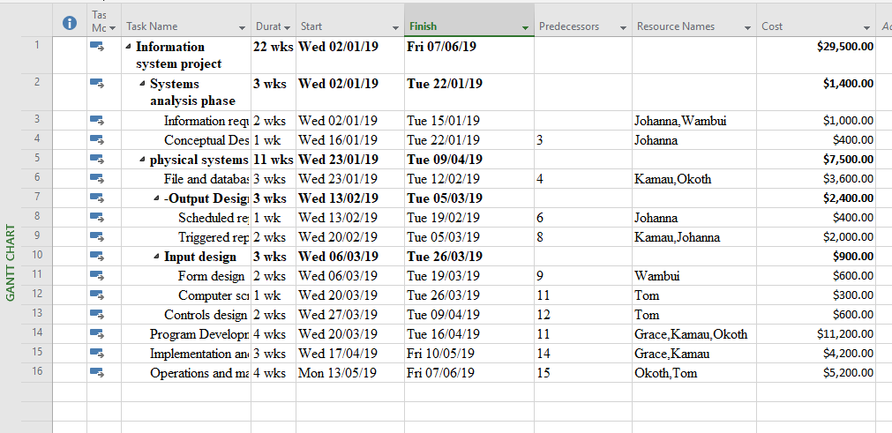

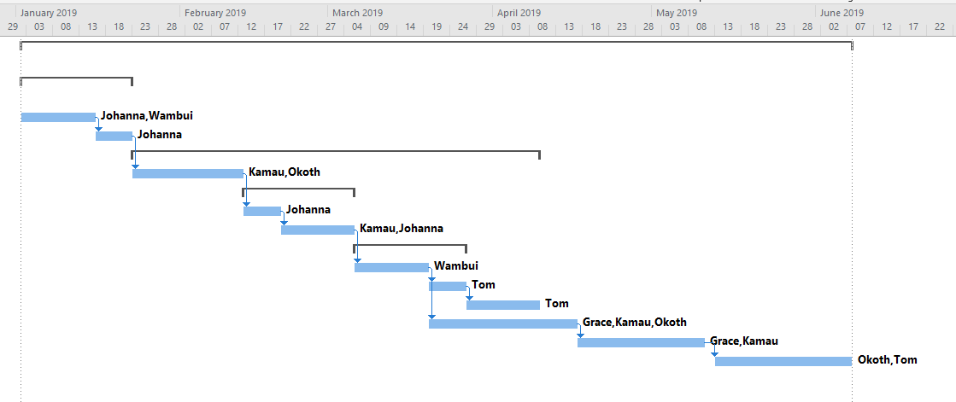

**2**

**(a) Make the above changes into your project, how long will the project take now?**

**18.5 weeks**

**(b) Save the data as the baseline plan for your project and make a printout including tasks, resource names, cost and Detail Gantt chart**

